Exercise: Cashier System

Objective:
Design a simple Cashier System that allows the user to:
1. Enter multiple product details.
2. Calculate the total sales amount for each item, including discounts.
3. Display the final bill with all items, discounts, and total amount due.
This project hands-on practice with Selection Control Structures (using if-else for discounts) and Repetition Control Structures (using loops for multiple products), along with concepts like Data Types, Operators, and Input/Output.

Instructions:
- Display Menu Options
The program should start by displaying a menu with the following options:
- 1. Add Product to Bill
- 2. Display Final Bill and Exit
- Add Product to Bill
For each product, prompt the cashier to input:
- Product Name (string)
- Unit Price (float)
- Quantity Purchased (integer)
Apply discounts based on the Quantity Purchased:
- 10% discount if the quantity is greater than 10 units.
- 5% discount if the quantity is between 5 and 10 units.
- No discount if the quantity is fewer than 5 units.
Calculate and store the total price for this product (with discount applied) for later display.
- Display Final Bill and Exit
Use a loop to display the names, unit prices, quantities, and discounted prices for each item.
Calculate and display the grand total amount due for all items combined.
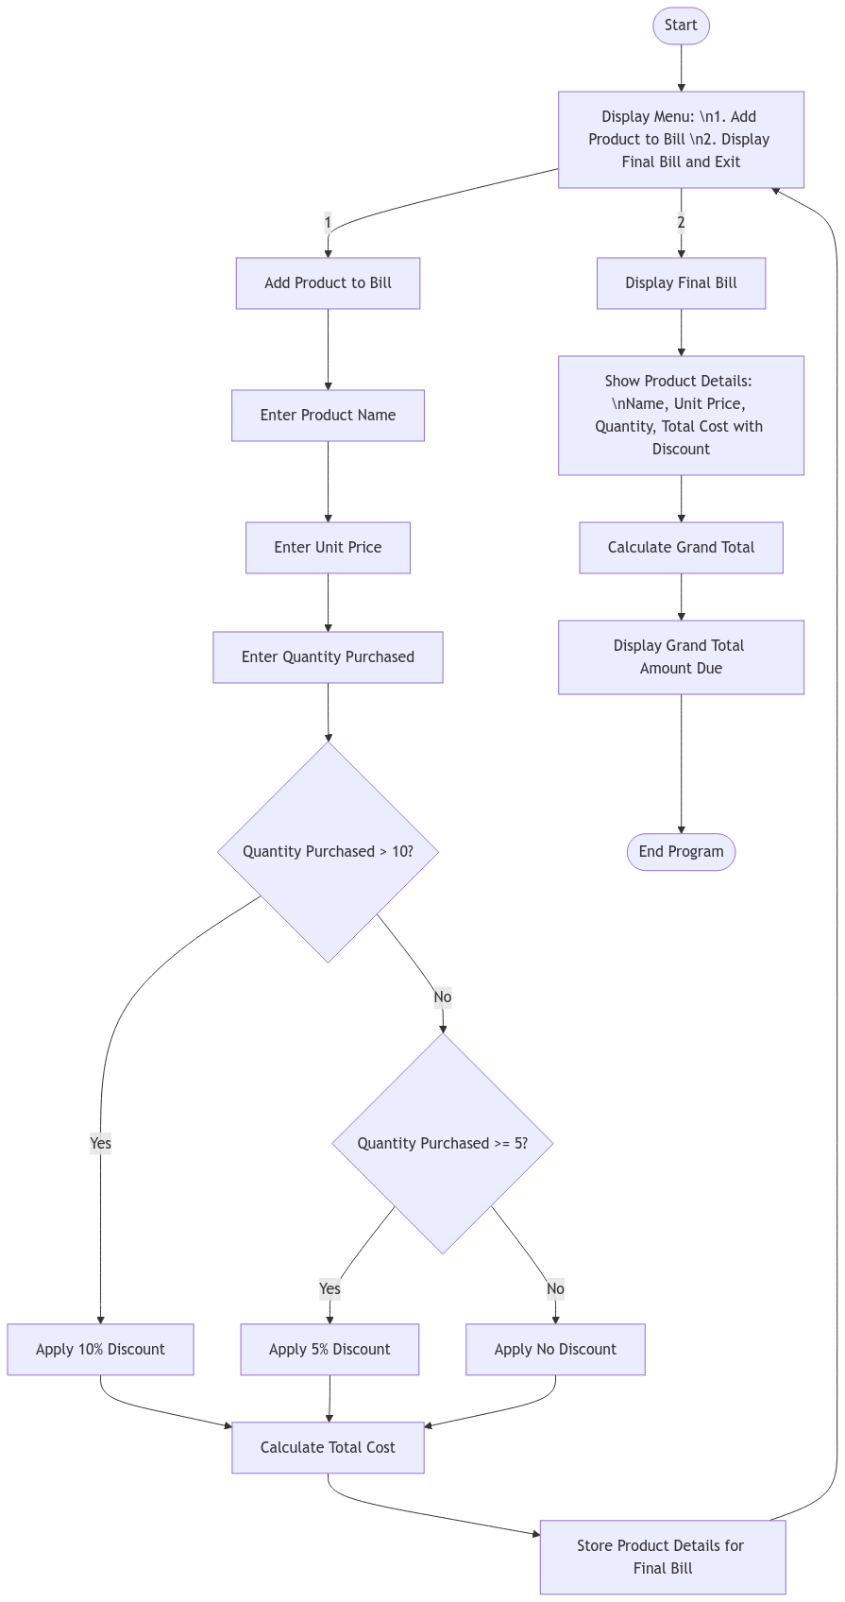

Flowchart for Cashier System:
Here's a flowchart for the Cashier System:

Sample Terminal Output:
